**EXPERIMENT 7**

**Arrays in Linux**

An array is a variable containing multiple values may be of same type or of different type. There is no maximum limit to the size of an array, nor any requirement that member variables be indexed or assigned contiguously. Array index starts with zero.

**Basic functionalities of an array**

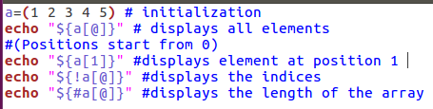

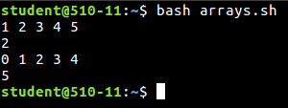

**# Reading values in an array and displaying them**

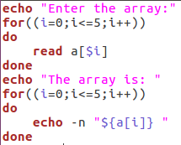

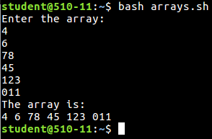

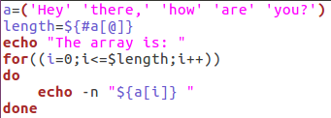

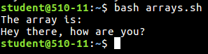

**Q. Searching the element**

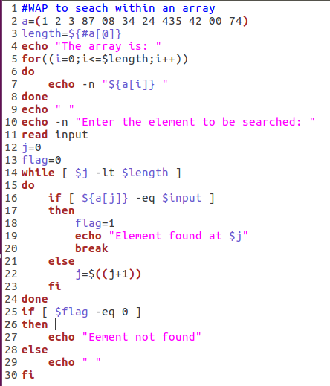

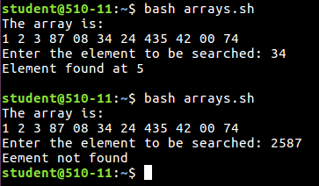

#Sorting an array

* **Bubble Sort**

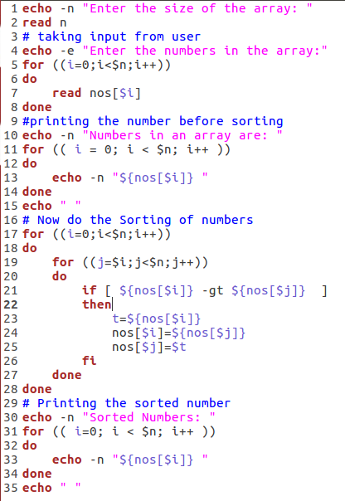

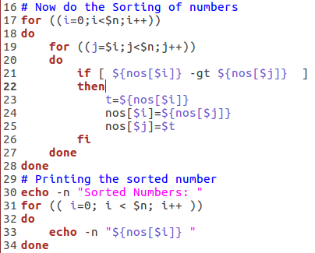



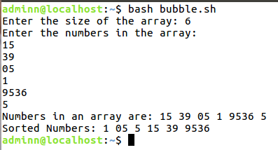

* **Selection Sort**

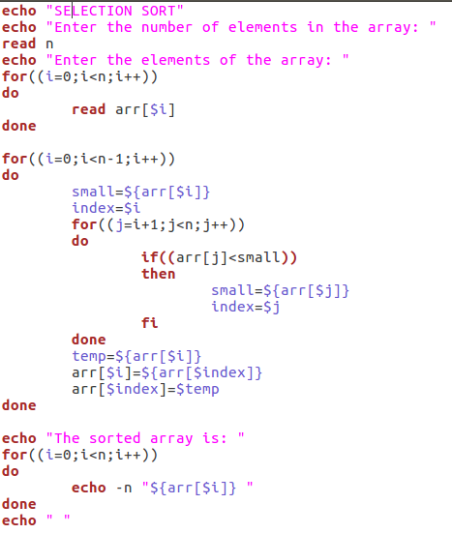



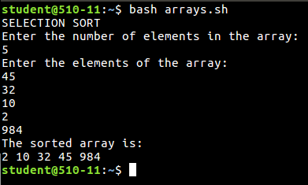

**#Functions**

Functions enable you to break down the overall functionality of a script into smaller, logical subsections, which can then be called upon to perform their individual tasks when needed.

Using functions to perform repetitive tasks is an excellent way to create code reuse. This is an important part of modern object-oriented programming principles.

Shell functions are similar to subroutines, procedures, and functions in other programming languages.

**#Simple function**

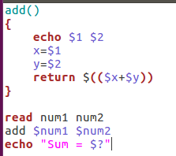

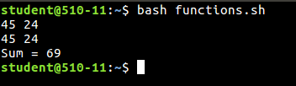

**#Selection Sort using functions**

